**PROJECT NAME : SWIGGY**

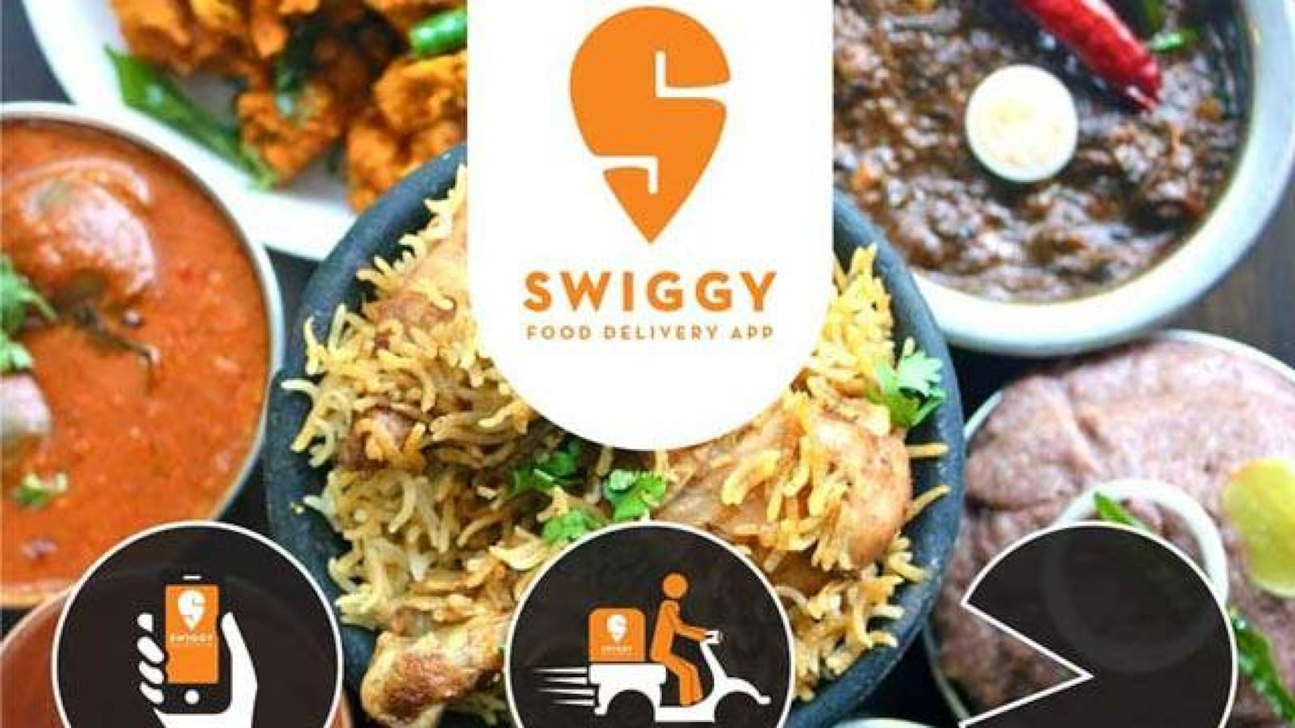

**OVERVIEW:-** Swiggy is **an Indian online food ordering and delivery platform**. Swiggy offers an online ordering platform for a variety of listed neighborhood partner restaurants.

**HOME PAGE:-**

* Company Name
* Logo
* Icons
* Search Bar
* Login/Create Account
* Sliders with Arrows
* Featured(Images)
* Location Selection
* Offers
* Help
* Footer – ( Contact us , Helplines , Brief descriptions about the company ,Social media handle icons,Link to mobile app)

**Menu bar**

* A horizontal division where different categories of meals are available to see.

**Main Page:**

* Filters: 1.Cuisines

2. show Restaurants with a)offers b)pure veg c) sort by

3. Price ranges

* IMAGES OF THE CHOSEN PRODUCT WITH DETAILS LIKE - (Relevance , Delivery time, Rating , DISCOUNT%, Price:High to Low, Price:Low to High
* Restaurant Description- Restaurant Name, types of Meal, Price, Discount(%) if any, Delivery options, Specification, Location, Ratings , customer Reviews with images(if any)

**Payment page:**

* Address Selection
* Payment Method: (Phonepay, Google pay,BHIM UPI,COD, Credit/Debit card, Net Banking,Paytm)

**Technologies Used In Swiggy:**

**Front-End:** 1. Html

2. Css

3. Bootstrap

4. React

**Dynamic:** 1. Javascript

**Database:** 1. Mongodb

**Code compilers**: 1. Visual studio code

2. Git bash

3. Git hub